# Speech

## Week/Lecture 1: Intro

Moodle:

* Everything’s clickable
* All need-to-know info is in the first table

Assessment:

* Quizzes (25%)
  + Start in Week 3
    - Open Monday 5 pm to following Monday 5pm
  + Aligned to seminar materials
    - half of quiz covers previous week’s seminar
    - other half prepares next week’s seminar topic
* Home Essay (25%)
  + Prompts released in Week 5, due in Week 10
  + Material from weeks 1-5
  + Choice of 3 topics (1 from each strand)
  + 1200 words (+- 10%), not counting bibliography
  + Week 5 seminar covers how to write an ELL essay
* Final Exam (50%)
  + 24-hour open period
  + 2 out of 6 essay prompts
  + Do not use substantially same material in both essay and final exam

What is Phonetics?

* **Science of Speech**
  + Uses scientific methods to test hypotheses
  + Interested in spoken language only
* Main approaches:
  + **Articulatory**: How are sounds formed in the vocal tract?
  + **Acoustic**: What properties do the soundwaves have?
  + **Auditory/perceptual**: What do listeners hear and perceive?
  + **Psycholinguistics**: How do speakers plan, execute, and make sense of speech?
* Phonetic research may focus on:
  + **Segments**: individual speech sounds (e.g., vowels, consonants)
    - Phonology (**phonemes**): **categories** with contrastive lexical meanings, e.g. in English, ***lead*** /li:d/ =/= ***read*** /ri:d/ (slash brackets // mean phonemes)
    - Phonetics (**allophones**): **members** of a category that do not change the meaning, e.g., rolling/not rolling r (square brackets [] category)
    - **Minimal pairs** are used to find out if a segment is a phoneme or an allophone
  + **Prosody**: patterns over larger units of speech (e.g., stress, rhythm, pitch; over syllables, words, utterances)

Why study phonetics?

* Speech is complex
  + It involves extremely fine and fast motor control to crate precise fluctuations in air pressure
  + Received and decoded as complex meanings
  + Most learn this without effort and use it every day
* We gain a lot of info from speech
* Uses:
  + Sociophonetics
    - Investigating how and why speakers from different social groups speak differently from each other
  + Pure phonetics
    - Describing how sounds are produced in a specific language/accent, e.g., to document, preserve, teach, and learn languages/accents
  + Sound change
    - How and why does spoken language evolve?
  + Speech therapy
    - Establishing differences between disordered and typical speech, finding strategies to work around them
  + Forensics
    - Looking for patterns that can identify and/or discriminate between individuals
  + Speech recognition and synthesis
    - Making sure technology can process and generate everyone’s accent
* Real-life phonetic research questions:
  + How is /s/ used to signal gender and sexual orientation?
  + Is /r/ at the end of words disappearing in Central Scotland?
  + Does wearing face masks affect speech intelligibility?
  + Do we speak to smart speakers or robots differently to how we speak to people?
  + Do choirs have different accents?

Accents

* Accent – system of pronunciation (spoken version of dialect)
* Everyone has an accent, no better pronunciation than others
* Can be large-scale (British, American, Indian English)
* Smaller scale (Scottish vs. English, Glasgow vs. Edinburgh, West End vs. South Side)
* Idiolect: speech patterns of one particular person

## Lecture 2: Anatomy, IPA, Vowels & Consonants

Phonetic tools:

* Instrumental
  + Audio recordings (analysed in speech processing software, e.g., Praat)
  + Articulatory equipment (MRI, EPG, ultrasound)
  + Listening experiments
* Impressionistic
  + Own senses (listening, repeating, feeling)
  + International Phonetic Alphabet (IPA)
  + Anatomical knowledge of the vocal tract

Vocal Tract

* Areas of the mouth, nose, and throat involved in speech
* Articulators – organs in the vocal tract used to produce speech
* Most speech sounds have a source and a filter
  + Vocal folds (source for most sounds)
  + Filter: size, shape & material of “tube”
    - Factors that affect filter:
      * changing from oral to nasal airflow
      * moving tongue
      * rounding lips
      * constricting throat
* Models:
  + Simple version: Duck whistle & rubber tube
  + Advanced version: Air pump & 3D printed vocal tracts
* Resonators
  + Spaces in the vocal tract where sounds can resonate
  + Nasal cavity
  + Oral cavity
  + Pharynx (above larynx)
    - Naso-pharynx
* Articulators
  + Mobile (active) or stationary (passive)
  + Larynx (voice box)
    - Vocal folds
  + Tongue
    - Fastest and most flexible
    - Moves in 3D
    - Controlled by multiple muscles
    - Parts (front to back):
      * Tip
      * Blade
      * Front
      * Back
      * Root
  + Teeth
  + Alveolar ridge
  + Lips
  + Hard palate
  + Soft palate (velum)
  + Uvula (“little grape”)

International Phonetic Alphabet (IPA)

* Writing system that does not belong to any language
* Systematic; removes problem of inconsistent spelling
* Can describe any sound in any language
* 1 symbol = 1 sound
* Manner of articulation (top to bottom)
* Place of articulation (left to right)

Consonants and Vowels

* **Consonant** – a sound produced with audible obstruction to the airflow
  + **Place of articulation** – **where** is the obstruction?
  + **Manner of articulation** – **how**
  + Voicing / State of the glottis – what are the vocal folds doing?
    - ‘glottis’ – space between the vocal folds
* **Vowel** – a sound produced with no audible obstruction to the airflow

## Lecture 3: Consonants, Places, Manners

Manners of Articulation:

* Plosive (stop)
  + Articulators are held together
  + Air pressure builds up behind the obstruction
  + Articulators then separate, releasing built-up air
  + Sounds like a tiny ‘explosion’
  + voiceless – p, t, k
  + voiced – b, d, g
* Nasal
  + Like a plosive, full closure in the vocal tract **plus** the soft palate is lowered, allowing air to flow out through the nose
    - no increase in air pressure
    - no ‘explosion’
    - continuous sound
  + Ex: m, n
* Fricative
  + Articulators are held together to form a narrow channel
  + Air is forced through the channel
  + Air becomes *turbulent*, resulting in noise
  + voiceless: f, th (thin), s, sh
  + voiced: v, th (the), z, zh
* Approximant
  + Articulators are held close together, but not close enough for air passing through to become turbulent
  + Ex: l, y, w, r (English)

Electropalatography

Places of Articulation:

* Bilabial
  + Lower and upper lip
  + Ex: p, b, m
* Labiodental
  + Lower lip and upper teeth
  + Ex: f, v
* Dental
  + Back of upper teeth and tip/blade of tongue
  + Ex: (th in thin), ð (th in the)
* Alveolar
  + Tip/blade of tongue, alveolar ridge
  + t, d, s, z, n, l
* Post-alveolar
  + Blade of tongue and back of alveolar ridge
  + Ex: tr in train, dr in drain, sometimes r
* Retroflex
  + Tip/blade of tongue curled back under hard palate
* Palato-alveolar
  + Tip/blade/front of tongue and alveolar ridge/hard palate
  + sh, zh, dzh
* Palatal
  + Front of tongue and hard palate
  + y ([j])
* Velar
  + Back of tongue and soft palate
  + k, g, h (loch) [x], ng in hang
* Uvular
  + Back of tongue, uvula, soft palate
  + [upside down r] in French radio, [
* Glottal
  + Vocal folds
  + h in hat, [glottal stop] in butter (bu-uh)
* Double articulation: **Labio-velar**place
  + 1 obstruction at lips
  + Another between back of tongue and velum
  + [upside down w] in which (hwich)

Manners (contd.)

* Affricate
  + Short plosive followed by short fricative at same place of articulation
  + The rims of tongue
* Lateral
  + Airflow is obstructed between midline of tongue and upper articulator
  + The rims of tongue are raised so that air can flow freely along one or both sides of tongue
  + l
* Tap
  + Articulators come into contact very briefly
  + Momentary interruption of air flow
  + Alveolar: r (Sc. English very, sorry)
  + Am. English butter (budder)
  + Retroflex: r (Am. English *party*)
* Trill

## Lecture 4: Vowels

Describing consonants:

1. Voicing
2. Place
3. Manner

Scottish voice recognition lift skit:

* Phoneme /t/, /r/:
  + Glasgow Scottish: glottal stop, t
  + Lift voice (General American): t
* Phoneme /l/:
  + Glasgow Scottish: ‘dark’ [ɫ]
  + ‘American’ accent: ‘dark’ [ɫ]
  + ‘English’ accent: ‘clear’ [l]
  + Lift accent: ‘dark’ [ɫ]
* Phoneme /r/
  + Glasgow Scottish: [tap]
  + Lift voice: [retroflex approximant]

Vowels

* Sounds without any obstruction in airflow (vocal tract)
* Not consonants:
  + manner & place describe obstruction
  + vowels are voiced
* Description:
  + Position of the highest point of the tongue
    - Overall tongue shape: convex (humped)
    - Top surface of tongue: highest point
  + Position of lips
    - Unrounded (spread)
    - Rounded

Vowel space -> vowel quadrilateral

* front-backness
* height

The Cardinal Vowels

* A system of abstract reference vowels
* Daniel Jones, early 20th century
* 18 cardinal vowels, 8 ‘primary’, 10 ‘secondary’
  + at the edges of the vowel space
* Primary

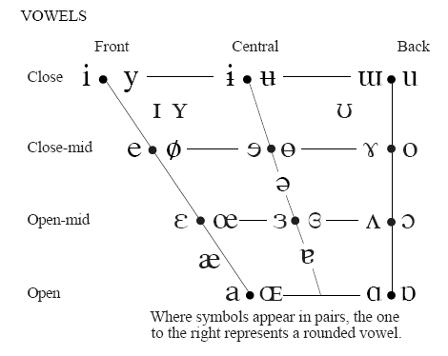

**1**

**2**

**3**

**4**

**5**

**6**

**7**

**8**

* Secondary:
  + 

Float vowels:

* Float vowel qualities ‘float’ across an area of quadrilateral
* Useful for describing vowels of English

Monophthongs and Diphthongs

* Monophthongs:
  + tongue and lips remain more or less still
  + led, bee, hoo noo broon coo?
* Diphthongs
  + tongue and/or lips move during vowel production
  + lied, boy, how now brown cow?

Description of vowels:

1. Tongue position: backness, height
2. Lip position: rounding

## Lecture 5: Stressed Vowels, Accents

Recap:

* Vowels
  + No obstruction to the airflow
  + Lip position – spread vs rounded
  + Tongue position – front/back, close/open
  + Monophthong vs diphthong – one/two targets
  + Cardinal Vowels – reference vowels

Describing vowel phonemes: closest symbol in // brackets

Finding phonemes – minimal pair test

* Pair of words that differs in only 1 phoneme and meaning
* e.g.:
  + pat, sat, mat (consonants)
  + pin, pit, pick (consonants)
  + heed, head, had (vowels)

Transcription:

* Phonemic – represents only lexically distinctive differences in sound
* Phonetic: represents more details of sounds (allophones)

Vowel systems in accents of English

* system – list of vowel phonemes in an accent
* The number of vowel phonemes varies
* Many Scottish accents have a system of 14 vowels
* RP has 19
* Stressed vowel system in Scottish English
  + seat /i/ - front close unrounded
  + sit /I/ central, fairly close, unrounded
  + set /epsilon/ front, open-mid,
  + pam, palm /a/
  + cot, caught /backwards c/
  + full, fool /u/
  + nose /o/
  + luck //
  + boy /backwards c e/
  + house /wedge u/
  + tide /wedge i/
  + tied /ai/

Stress

* Extra loudness or prominence that is given to a syllable
* diacritic ‘ just before the stressed syllable
  + ex: ‘button
* Whisper test: by whispering, loudest syllable is stressed

What we need to know about vowels:

* Main 3 parameters
* Cardinal (what and why needed)
* Regional differences in stressed vowels

Phonetics in action – comparing accents

* Phonemic system
  + the number and nature of the phonemes
  + ex: ScE has 2 more consonant phonemes than many varieties of English:
    - /x/ loch forms a minimal pair with lock /k/
    - /upside w/ whine forms a minimal pair with wine /w/
  + ex: ScE has 1 vowel phoneme
    - /a/ (Sam = psalm), where RP has 2 /a different a/ (Sam, psalm)
* Phonetic realisation of phonemes
  + all accents contrast /I/ and /i/ (sit and seat), but different accents realise /I/ differently:
    - Glasgow/RP/Australia/New Zealand
  + all accents have /l/ but different accents realise it differently
    - RP lit [l] vs till [crossed out l]; ScE [crossed out l] (‘dark’, velarised lateral)
* Which sequences of phonemes are allowed
  + /r/ is possible after vowels in ScE, IrE, AmE (rhotic accents) car /kar/, heart /hart/
    - most EngE are non-rhotic /ka/, /hat/
  + what consonants /j/ can follow (yod-dropping)
    - /b/ beautiful, Bute
    - /n/ news, newt
    - /s/ suit, super
* Choice of phoneme in particular words
  + December, assume, tomato, basil, herb
  + Phoneme selection, lexical incidence

# Varieties of English

## Lecture 1: Varieties and Variation, Indian English

Linguistic description

* Phonetics/phonology
* Grammar
* Lexis (vocabulary)
* Iconic features

Contextual description

* Historical
* Geographical
* Cultural
* Social
* Contact

Variation in the English language

* At home and abroad
* More widely used than any other language
* ~1.5 billion speakers
  + almost ¼ world’s population
* Largest vocabulary (OED – ½ million words)
* ¾ world’s mail, email etc
* A lot of advertising in English

Who speaks English?

* Native speaker
  + i.e., acquires language naturally as first language (mother tongue)
  + c. 400 million native speakers
  + British Isles, North America, Caribbean Southern hemisphere: Australia, New Zealand, South Africa
* Non-native speakers of English
  + English is spoken in addition to a native language
  + >1 billion
  + **lingua franca**
    - language of wider communication
  + English as a Second Language (**ESL**)
    - e.g., India, Gambia, Kenya (c. 400 million) official language, lingua franca, education
  + English as a Foreign Language (EFL)
    - e.g., Germany, Japan, France (c. 700 million), lingua franca, increasingly also for education

Kachru’s ‘circles’ of English (Braj Kachru):

* **Inner Circle**
  + English as a 1st language
  + British Isles
    - Irish/Scots Gaelic; community languages (Punjabi)
  + North America
    - 40 million, also Spanish
    - Canada (bilingual)
  + Australasia/South Africa
    - c. 20 million Australia/NZ
    - 10% population of S Africa native English speakers (11 official languages)
* **Outer Circle**
  + English as a 2nd language
  + former British colonies
    - Kenya, India, Malaysia
  + English tends to be an official language
    - admin
    - edu
    - media
  + ex: India (~350 million speakers)
* **Expanding Circle**
  + English as a foreign language
    - Industry, business, politics, diplomacy, education, research, sports, entertainment
  + Expanding/expanded?
    - English in Japan
      * 17th century onwards:
      * 20th century: English emerged as principal source of new words
      * Loanwords:
        + hoteru, elebeetaa, ereganto, sakkaa, shawaa, kyattu fuudo

Case Study: **Indian English**

* History:
  + British probing into India for trade: early 1600s
  + The Raj – a period of British rule in India that lasted until Independence in 1947
  + 1700s: English established as language of administration
  + Late 1800s: first English novel in Hindi
  + 19th cent.: English increasingly accepted as the language of government, of the social elite, and of the national press
* Current situation:
  + People read more in English than Hindi

## Lecture 2: Variation by Use and User

Variation according to **Use** (**register** variation)

* Medium of communication
  + Ex: speech/writing
* Area of activity
  + Ex: advertising, journalism, children’s story, etc

Linguistic variation according to **user** (**sociolinguistic** variation)

* Regional
  + Brummie, Geordie, Cockney, …
* Social
  + class, gender, age, ethnic origin

Terminology

* General:
  + Language
    - “the whole body of words and of methods of combination of words used by a nation, people or rase; a ‘tongue’” (OED)
    - ‘A language is a dialect with an army and a navy’
  + Dialect
    - “One of the subordinate forms or varieties of a language arising from local peculiarities of vocabulary, pronunciation, and idiom” (OED)
  + Relationship between language and dialect
    - Languages are often mutually unintelligible, e.g., English, French, German
    - Dialects of a language are often mutually intelligible, e.g., London English, American English
    - BUT languages are not always mutually unintelligible, e.g., Danish, Swedish, Norwegian
    - AND dialects are not always mutually intelligible, e.g., Chinese (Cantonese, Mandarin), English (Scouse, Newcastle)
* Linguistics:
  + Accent
    - The pronunciation of a language
    - 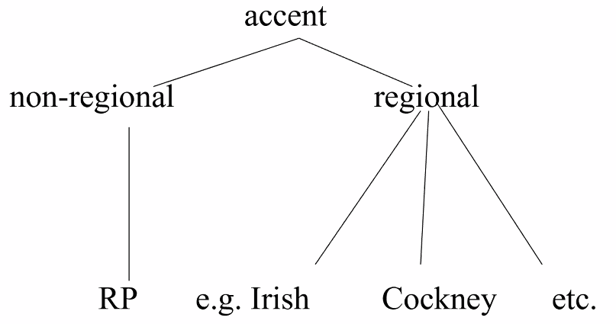
    - Received Pronunciation (RP)
      * RP – non-regional, social accent of English
      * ‘received’ – Victorian term for ‘socially acceptable’ (upper/middle class society)
      * associated with ‘the great public schools’, e.g., Eton, Harrow, Winchester, etc
      * ~3% population of England speak RP
  + Dialect
    - Varieties of a language which are lexically, grammatically and phonologically different from each other
    - In ELL, dialect refers to all varieties of a language (regional and non-regional)
    - Usually, people refer to regional dialect
  + Variety
    - Neutral term to refer to forms of language without classification as dialect/language, etc
    - Ability to refer/describe forms of language which vary according to factors as well as regional ones, e.g., social (gender, age, class), register
* Standard/Non-Standard
  + Standard – refers to lexis and grammar
  + Standard English doesn’t usually contain regional lexis/grammar
  + Non-Standard English usually contains regional lexis/grammar
  + Written English
    - Formal written English uses Standard English
    - Many people still use Standard English for informal writing
    - Non-Standard spelling:
      * 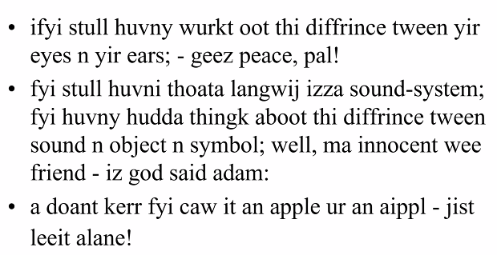
  + Accent
    - Standard English can be spoken with a non-regional accent (RP)
    - Standard English can be spoken with a regional accent
    - Non-Standard is spoken with a regional accent
  + Perception
    - Standard
      * Logical, more elegant, more sophisticated, ‘correct’
      * Threatened by degeneration, innovation and outside influences
    - Non-standard
      * Wrong, full of errors
      * Illogical, has no rules, constantly changing, full of lazy pronunciations
  + Rise of Standard English
    - 17th century: English began to be used widely in publication
    - A widely intelligible standard was needed so English began to be codified
    - 18th/19th century: prescriptive grammars began to be published to tell the people what ‘the standard’ was – what was ‘right’ and what was ‘wrong’
    - Trudgill 1983: ‘Standard [dialects] and prestige accents acquire their high status directly from the high-status groups that happen to speak it’
    - Opinions concerning non-standard English are neither **objective** nor based on linguistic knowledge: they are **subjective** and **socially based**

## Lecture 3: Myths, Sociolinguistics

Examples of **non-standard English being more logical** (having stricter rules):

* Present tense
  + Non-standard English
    - *talks* with every pronoun
  + Standard English
    - *talk* with every pronoun except he/she/it
* Reflexive pronouns
  + Non-standard
    - Myself, yourself, hisself
  + Standard
    - Myself, yourself, himself/herself
* Past tense forms variability
  + Non-standard
    - I worked/ I have worked
    - I seen him/ I’ve seen him
    - I spoke to her/ I’ve spoke to her
  + Standard
    - I worked / I have worked
    - I saw him / I have seen him
    - I spoke to her / I have spoken to her
* Pronominal system
  + Non-standard
    - Yous leave now! All of yous!
    - Yous – polite form singular
  + Standard
    - You leave now! All of you!

**Non-standard English rules** (different from standard)

* Coordinate structures
  + Standard English
    - Jonathan and I are going
  + Non-standard
    - Jonathan and me are going
    - Me and Jonathan are going
    - ~~I and Jonathan are going~~
* Passive forms
  + Standard
    - The window was broken
    - The broken window
  + Non-standard
    - The window was broke
    - ~~The broke window~~

**Variation (both show linguistic variation, both are constantly changing)**

* Non-standard
  + You *was* there, *weren’t* you?
  + I didn’t do *anything*, I told you I didn’t do *nothing*.
* Standard
  + You *have to* do it / You’*ve got to* do it / You *must* do it
  + When I was young, I *went* to school every day / When I was young, I *used to* go to school every day

Difficult pronunciation (non-standard English can be as or more phonetically complex than standard English)

* Varieties other than Scottish English
  + Short: beat
  + Long: bead, bean, beam, beer, breathe, bee, bees
* Scottish Vowel Length Rule
  + Vowels are short except before /r/, voiced fricatives and a morpheme boundary
    - Short: bean, bean, beam
    - Long: beer, breathe, bee, bees

Prescriptivism vs descriptivism

* **Prescriptivists** want to tell you how you **ought to speak**
* **Descriptivists** want to tell you how people **actually speak**

Dialect and accent variation

* Twitter: @tweetolectology
* How to get info on dialects:
  + (traditional) dialectology
    - Systematic study of differences in language varieties
    - Regional differences in varieties
    - Methods:
      * pen/paper interviews
      * digital surveys
    - Survey of English dialects (SED)
      * Harold Orton, University of Leeds
      * 1950-61
      * To complete a Linguistic Atlas of England
      * Selection of locations
        + Rural communities favoured over urban localities – traditional dialect best preserved in rural areas
        + Avoid newly developed localities to evade the linguistic influence of dialect contact
        + Stable population of approximately 500 inhabitants for 100+ years
      * Selection of informants
        + Males rather than females
        + 600 years or over
        + All from working class
        + NORMs – non-mobile older rural males
      * Questionnaire
        + Blanks in sentences for people to fill in
    - Digital dialectology
      * [www.ourdialects.uk/index.html](http://www.ourdialects.uk/index.html)
      * <https://englishdialectapp.com>
        + map posted on @tweetolectology
    - Result: Linguistic atlases
      * Display maps
      * Indicate responses geographically
      * Indicate generalisations from display maps
    - Dialectology
      * allows us to see how variaties of English vary according to geography
      * at all 3 levels of language
        + lexis: e.g., ‘bread roll’ = roll, bun, bap, cob, barm, …
        + phonology: e.g., CUT/FOOT
        + grammar: e.g., I done it/ I’ve done it
    - Dialect boundaries
      * **isogloss** – line marking the boundaru between 2 regions which differ with respect to some linguistic feature (e.g., a word or its pronunciation)
      * Ex: Phonetics/phonology: pronunciation of the word CUT
        + isogloss can move
    - Micro-dialects
  + Sociolinguistic research
    - Pioneered by William Labov
    - Sociolinguistics (urban dialectology)
      * from 1960s onwards
      * Systematic study of regional and social differences in varieties
      * Informants from all strata of society
      * Data collection mostly through the sociolinguistic interview or participant observation
    - Differences
      * Class
        + Examples:

Lexical: dinner/supper

Phonological: coke (cook), super, singing

Grammatical: I didn’t do nothing, have you money?

* + - * + Upper:

Less regional variation

non-regional accent (RP)

standard dialect

**prestige**

* + - * + Working:

more regional variation

regional accent

non-standard dialect

**stigma**

* + - * Style
        + In more formal styles, people start using more prestige forms, i.e., they try to sound more ‘posh’
      * Gender: next lecture
* Other factors influencing variation

## Lecture 4: Social Factors, Dialect Change, Attitudes to Accents

Gender

* ‘Women have smaller vocabulary than men, use simpler sentence structure than men, speak with little prior thought’ (Jespersen 1922)
* ‘the **myths** of Mars and Venus’ by Deborah Cameron at [www.guardian.co.uk/world/2007/oct/01/gender.books](http://www.guardian.co.uk/world/2007/oct/01/gender.books)
  + 1 Language and communication matter more to women than to men; women talk more than men
  + 2 Women are more verbally skilled than men
  + 3 Men’s goals tend to be about getting things done
  + 4 Men’s way of using language is competitive, reflecting their general interest in acquiring and maintaining status; women’s use of language is cooperative, reflecting their preference for equality
* Evidence
  + Review of 56 research studies observing both genders in a single interaction (James and Drakich (1993)) about “women talk more than men”
  + 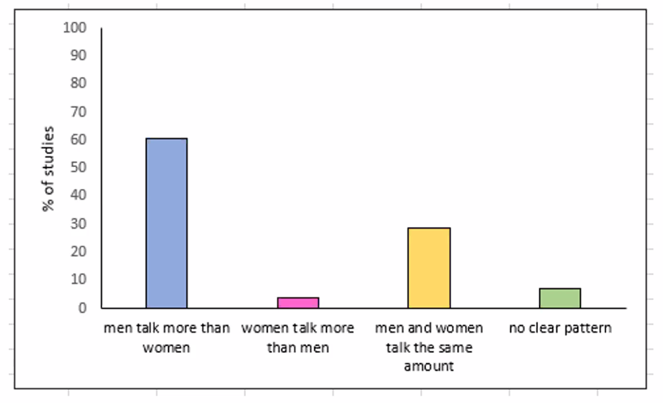
* Linguistic variation
  + Prestige
    - Women use higher rates of prestige forms than men, i.e., they try to sound ‘posh’
    - The difference increases in formal contexts
    - Women *think* they use more prestige forms than they actually do
  + Trudgill’s (1974:94) study of Norwich [-in] in, e.g., *singing*
    - 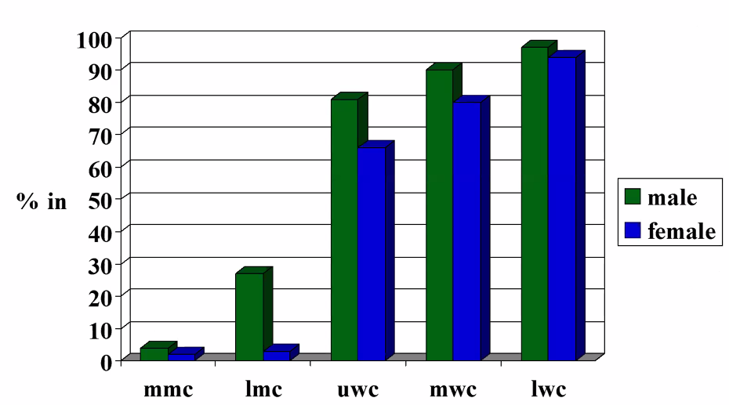

Age

* Lexical
  + *lit, yeet,*
* Grammatical
  + Like
    - ‘I was *like* “What??”’ (quotative)
    - I was there for *like* three years (discourse)
  + I’m *so* not gonna do that
  + I *done* it yesterday
* Phonological
  + *super, suit* (swuper, swuit)
  + *think* (fronting)
  + *people*

Language is constantly changing, youth are the innovators

* Dialect levelling
  + “a process whereby **differences** between regional varieties are **reduced**, features which make varieties distinctive **appear**, and **new features emerge** and are adopted by speakers **over a wide geographical area**” (Williams & Kerswill, 1999:149)
  + Young speakers in particular are noted to avoid ‘variants which they perceive to be particularly indicative of their local roots’ (Foulkes & Docherty 1999:13)
  + Traditional local forms into **Supralocal forms** (like *like*)
  + Examples:
    - TH-fronting [f] for // in, e.g., *think* observed in studies over time
    - Kerwell, *The Economist* 04.06.2011, Regional accents that will take over England
    - Glaswegian
      * Adopting some new features (TH-fronting, L-vocalisation)
      * Other changes, e.g., to its vowels, which are not at all like English south of the Border
      * => Changing, but remaining distinctive
  + Reasons for happening
    - Mobility has increased (planes, trains,
    - Social networks, gaming (communication increased)
    - TV

Attitudes to accents/dialects

* “It is impossible for an Englishman to open his mouth without making some other Englishman hate or despise him” (Pygmalion by George Bernard Shaw)
* All speakers hold attitudes to accents/dialects
  + e.g., Scottish accents – ‘friendly’, ‘trustworthy’
  + e.g., RP – ‘educated’, ‘intelligent’
* Attitudes to accents are **subjective**
  + No linguistic basis
  + Often **prejudices**
  + e.g., glottal stop in English, in, e.g., *butter*
    - but in Arabic it’s an elegant aspect of ‘good’ pronunciation
    - => same linguistic feature is perceived differently according to context
  + Stigmatised features of ‘incorrect’ pronunciation
* *shibboleth*
  + The Bible, Judges X11, 4-6
    - Gilead had s, sh
    - Ephraimites had only s
  + Linguistic feature which is regarded as typical of an area/group and used to define that area/group
  + Often regarded in a negative way
* Measuring attitudes to accents/dialects
  + Direct
    - Subject asked to directly talk about language attitudes
    - e.g.,
      * Questionnaires
        + “I like my accent”, “rank accents according to pleasantness/prestige/helpful for a career” (BBC Voices poll)
  + Indirect
    - Subject doesn’t know that their language attitudes are being investigated
  + Measuring towards…
    - responses to accent labels (‘Cockney’, ‘Queen’s English’, etc)
    - responses to audio recordings of speakers’ accents
  + Subjective reaction tests
    - Listeners listen to more than 1 speaker
    - Rate speakers according to traits, e.g., intelligent, trustworthy, ugly, bossy, poor, etc
    - Listeners are likely to know that the speakers are different people
  + Matched guise tests
    - Listeners listen to recording of different varieties
    - Recorded by the **same** speaker
    - Rate speakers according to traits
    - Demonstrates listeners’ attitudes to varieties, not the speakers, i.e., their linguistic prejudice
  + Key attitudinal studies on English accents
    - Late 1960s (Giles 1970)
    - Mid 2000s (e.g., Coupland and Bishop 2007)
    - Late 2010s (Accent Bias Britain)
* Has public perception of accents changed over time?
  + 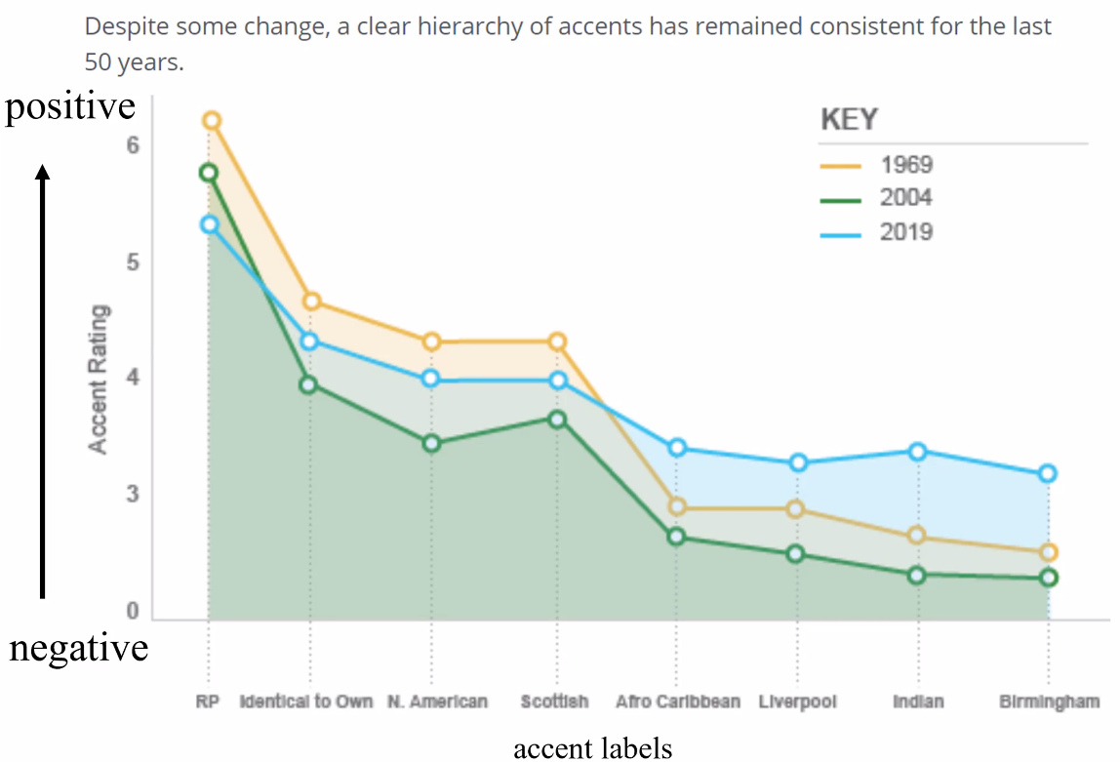
  + 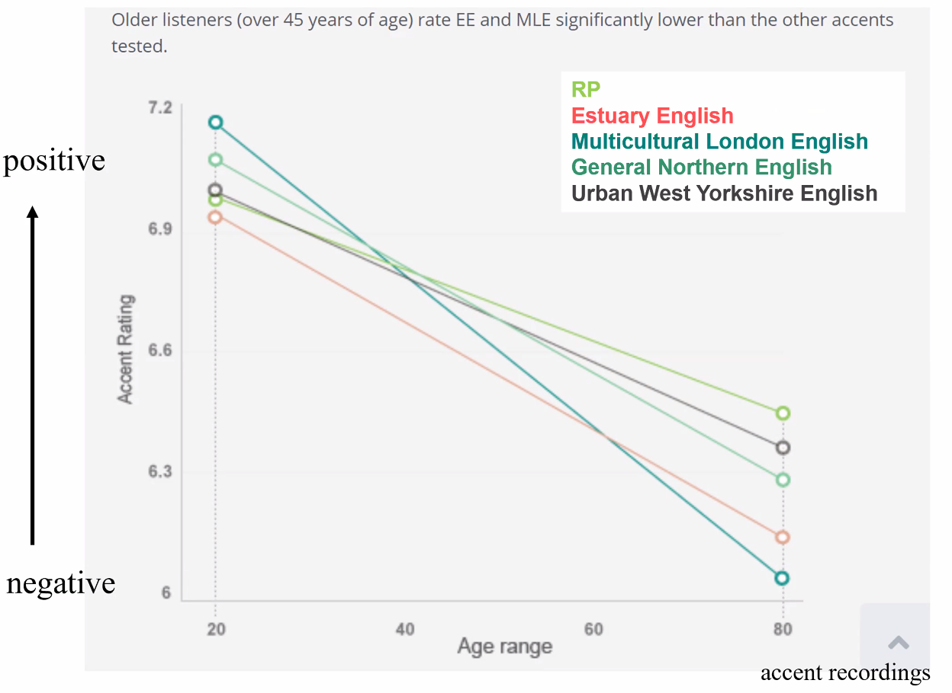
* Perceptual Dialectology
  + What mental maps of accents do people have?
  + What do they think of these speech areas (smart, polite, formal, nasal, etc)?
* Why should we care about people’s attitudes?
  + “As accent is not protected by the Equality Act 2010, it can function as a proxy for other forms of discrimination, for example against ethnic, class, or regional groups.”
  + linguistic discrimination/’accentism’
* See Glesca accent, see nae job
  + *The Herald, 2.1.97*

## Lecture 5: English Overseas, English in Contact

What to do about accent bias

* Increase **cognitive control**
  + **raise awareness**
  + identify irrelevant info
  + commit to fairness and objectivity
  + increase accountability
  + appeal to diversity

### English Overseas

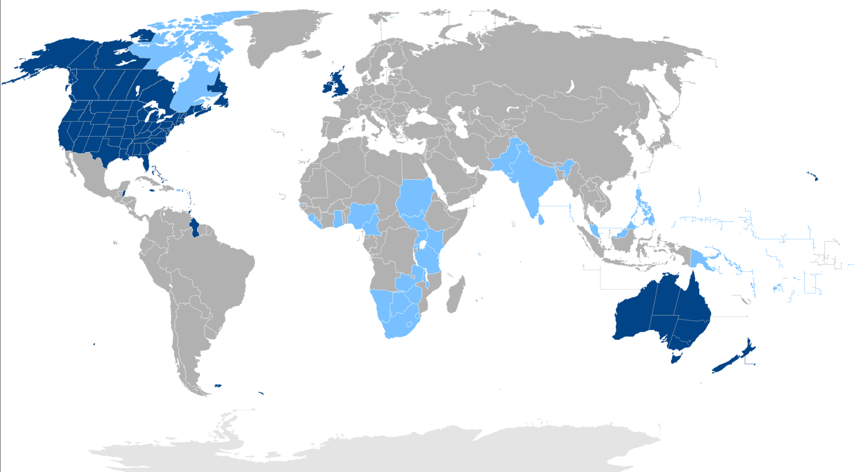



Inner Circle of English (First diaspora (scattering/dispersal) of English

* English transported to the ‘new world’
  + North America (USA, Canada)
    - Henry Sweet: ‘in another century … England, America, and Australia will be speaking mutually unintelligible languages, owing to their independent changes of pronunciation’ (1877: 196) (A Handbook of Phonetics)
  + Australia, New Zealand, South Africa

Outer Circle (2nd diaspora):

* Primarily 18th/19th cent.
  + West Africa (Gambia, Sierra Leone, etc)
    - arises mainly from slave trade, English is lingua franca
  + East Africa (Kenya, Uganda, etc)
    - Uganda – English as official language
    - Kenya – English as lingua franca
  + South Asia (India, Pakistan, etc)
    - East India Company, 1835 Macaulay ‘Minute’
    - English educational system in India
  + South-East Asia (Singapore, Malaysia, etc)

Key factors in the development of Overseas English:

* **Date** of settlement and language change
  + 2 phases of 1st diaspora
    - British English 1607 to America (2nd expedition) and 1620 to America (Pilgrim fathers)
    - British English 1788 to Australia (penal colony) and 19th-20th cent to Australia (Gold rush
  + Differences visible in rhoticity (car vs cah)
* **Regional varieties**
  + East English to America (Pilgrim Fathers), Australia, South Africa
  + West English to America (2nd expedition)
  + Cockney to Australia
  + Scottish to New Zealand, America

Case Study – American English

* History:
  + 1st expedition 1584
  + 2nd expedition 1607 (west country, London)
  + Pilgrim Fathers 1620 (East England)
  + 18th cent. Scots and Northern Irish
  + 1840s Southern Irish
* Linguistic traces/relics
  + I was so *mad*
  + Dave was really *sick*
  + Change the *diaper*
  + Come *fall*, the leaves start to fall
* Lexis
  + Other sources:
    - *chipmunk, pecan, squaw* (American Indian)
    - *lasso, chocolate* (Spanish)
    - *crevasse, cent, dime* (French)
    - *waffle, cookie* (Dutch)
* Phonology
  + *car (cah), lord (lohd)*
  + *bath (baeth)*
  + *bother (buhther)*
  + *Tuesday, tune, news (*yogh/ /j/ dropping)
  + *later* (ladder)
  + *winter (winner)*
* Spelling
  + Webster’s 1828 dictionary argued for many “simplification” to the idiomatic spelling of the period
  + *fiber (fibre)*
  + *color (colour)*
  + *sox (socks)*
  + *realize (realise)*
* Grammar
  + *Did you finish yet?*
  + *I already ate*
  + *get, gotten*
  + *She left Thursday*
  + *On the weekend*
  + *sneak, snuck* (EE sneaked)
  + *dive, dove* (EE dived)

Case Study – Canadian English

* History
  + 1497 – Newfoundland
  + 16th cent. exploration
  + 1776 – American Revolution – Loyalists fled to Canada
  + 19th/early 20th cent. subsequent settlers including Scotland

Australasian English

* History
  + Australia
    - 1770: Cook and the *Endeavour*
    - 1788: Penal Colony (New South Wales)
      * One ship *Buffalo* (including Ann Shepherd (from convict records website)
    - 19th/20th cent. emigration
  + New Zealand
    - 18th cent. whaling station
    - 1840: Treaty of Waitangi
* Australia
  + Lexis
    - *sod, bleeding, mate, dear, chum, love, duck* (Cockney)
    - *creek* ‘stream’, *tucker* ‘food’ (English)
    - *kangaroo, boomerang, billabong, walkabout* (Aboriginal)
  + Phonology
    - non-rhotic
    - BED vowel (like *bid*)
    - GOOSE vowel (like *goise*)
    - high rising terminal (HRTs)
      * *My name is Jane.* (like *My name is Jane?*)

### English in Contact

Linguistic consequences of contact

* Bilingualism
  + Some myths:
    - Bilingualism is rare
    - Bilinguals have equal and perfect knowledge of their languages
    - Mixing languages is a sign of laziness
    - Bilinguals have double/split personalities
  + Beneficial:
    - Greater mental flexibility
    - Ability to think more abstractly, more superior concept formation
    - Enhanced metalinguistic awareness (and literacy development)
    - More divergent/creative thinking
    - Enhanced communicative sensitivity
* Language mixing
* New Languages - Pidgins and creoles
  + Examples:
    - English-based pidgins and creoles:
      * Tok Pisin (Papua New Guinea, Pacific)
      * Cameroon Pidgin English (Cameroon, West Africa)
      * Nigerian Pidgin English (Nigeria)
      * Jamaican Creole (Caribbean)
      * Hawaiian Creole English (Hawaii)
    - French-based:
      * Haitian Creole (Haiti)
      * Mauritian Creole (Mauritius)
    - Spanish-based
      * Palenquero (Columbia)
      * Chavacana (Philippines)
  + Myths:
    - Corrupt, primitive
    - No grammatical rules
    - Mutually intelligible to speakers of the lexifier (language from which words are taken with local grammar)
  + Reasons for existing:
    - Need for communication for trade, work, etc
    - Speakers do not share common language
    - Functional language
  + Pidginisation – process of a pidgin being created
    - e.g., English as the **lexifier** (vocabulary being taken) and an African language as the **substrate** (syntactic structures)
  + **Pidgin**
    - No native speakers
    - **Restricted pidgin** – from marginal contact for limited purposes
    - **Extended pidgin**
      * used more extensively by multilingual community
      * may be official language (e.g., Tok Pisin in Papua New Guinea)
    - Lexis
      * Mostly taken from lexifier (English, French, etc)
      * Small vocabulary: Tok Pisin – 1500 words; some as little as 100 words
      * **Reduplication**
        + *tok* ‘talk’ (Pacific); *toktok* ‘chatter’
        + *luk* ‘look’ (Pacific), *lukluk* ‘stare at’
        + *fain* ‘lovely’ (Atlantic), *fainfain* ‘very lovely’
      * **Compounding**
        + *switmot* < sweet + mouth = ‘flattery’
        + *daiman* < die + man = ‘corpse’
        + *bigman* ‘important person’
      * **Circumlocution**
        + *gras* ‘something that grows’, *gras bilong het* (growing on head) ‘hair’, *gras bilong fes* (growing on face) ‘beard’
    - Grammar
      * **Grammatical simplification**
        + no plural marking for nouns

*i get di buk dem* (he has the books)

* + - * + pronoun system

1st singular *mi*/1st plural *mi ol*

* + - * + tenses/negation marked outside verb

*mi wok asde* (< yesterday [past marker]) – ‘I worked yesterday’

* + - Phonology
      * Avoidance of ‘difficult’ (complex) sounds (affricates, consonant clusters, etc)
        + *bandage -> banis*
      * CV structure
        + *six -> sixis, straight -> sitirit*
  + **Creole**
    - In general:
      * When a pidgin becomes the mother tongue of a speech community
      * Range of functions increases
      * Lexis expands
      * Syntax becomes more complex
      * Process of becoming a creole – **creolisation**
        + Decreolisation – when a basilect (less prestigious variety) becomes an acrolect (most prestigious) (through contact)
        + Recreolisation – when an acrolect becomes more like a basilect
    - Examples:
      * Jamaican Creole in London
        + main migration after WWII – labour shortage
        + from Caribbean, 1948 – mid 1970s
        + wide range of language varieties
        + 60% from Jamaica, also from Trinidad, Guyana, Barbados
      * British Afro-Caribbean English (British Black English)
        + *dat* ‘that’, *mout* ‘mouth’
        + syllable timed rhythm (British English stress timed)
        + simple present tense forms for past: *dis car pull up*
        + no plural marking: *two gal*
        + pronominals: *him say/me say*
        + lexis: *youthman, babyfather, spar(s)* ‘friend’, *donsi* ‘money’
      * Multicultural London English (MLE)
        + dialect of London English used in multi-ethnic areas since early 1980s
        + language contact with London Cockney
        + Influences:

Afro-Caribbean English, African Englishes, Indian English

huge number of languages, including Panjabi, Bengali, Tamil, Yoruba, Akan, Arabic, Turkish (300+ spoken in London)

* + - * + Features

***This is me*,** *‘Let’s get out of here’*

*man’s* looking at

*house*